**Elastic file system**:

storage offered by Amazon and it has a lot of features which resembles to NFS systems or Samba share.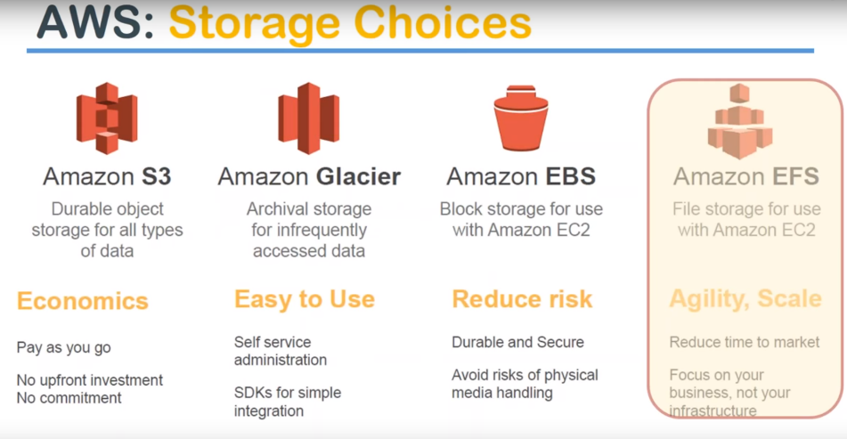

file storage🡪 EFS is your answer

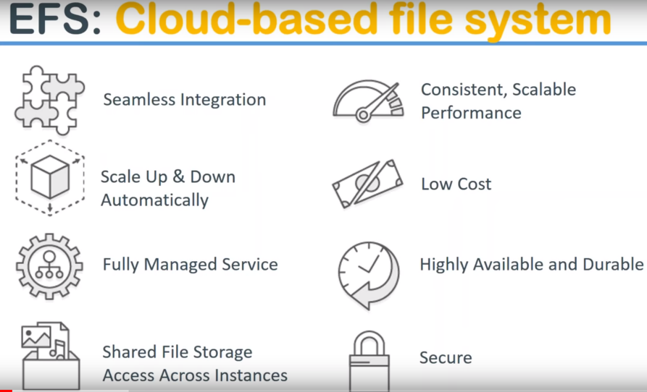

**seamless integration:**

you can integrate your ec2 instances, you can put it inside your V PC, you can have encryption configured on top, you can how the EFS file system available in different availability zones ..

EBS : AZ specific .When we are talking about EFS, it can span across availability zones but within the same region.

So seamless integration is to multiple services monitoring security by VPC security by encryption and also in terms of ec2 instances it can support so all the services are nicely smooth integrated.

**scales up and down automatically** you don't have to do anything on the storage like we do in EBS. If you put that in the MB of data you are going to be charged for 10 MB, if you are going to be putting 1 terabyte it is are going to be charged for that and next day you come back to 5 terabyte, then of course you can go ahead with that so it scales up and down automatically.

The performance for that kind of storage is also scaling up and down it is not just your size increases and decreases the performance also increases and decreases .

You have an option to say that I want Provisioned disk ..Provision IOPS, so that you will get consistent input-output speed in your EFS file system and once again.

It is a **fully managed service** so whenever you hear that the first thing that you need to get into your thinking is the installation configuration maintenance of updates patches security updates all those things are done by Amazon. you don't have to touch anything you just go ahead and consume it.,and don't have to worry about the management.

**Shared Files storage:** when you create an EFS file system you can have multiple ec2 instances reading and writing to the same file system at the same time in real time.

So the file lock mechanism or corruption avoidance all those things are built into the file system itself.

NFS has those protocols and you don't have to worry about doing anything of your own.

**Ex:** you can go ahead and configure ten different machines in different availability zones and they can all write to the same file system and it is fantastic in that way.

**consistent** **performance** because you can configure provision IOPS ,as we saw in EBS volumes so you can dial up your performance or dial down as well.

**low cost** when comparatively when you compare the other storages that are in the same market that is file based storage in the cloud managed services security EFS is a quite cost competitive I would say if you just look at it as a separate storage without any reference point it doesn't look look cheap.

But when you take up or talk about a fully managed secure consistent performance and seamless integration then the cost really becomes compelling to go ahead and use this service.

**Highly available and durable** because this service is built on top of s3 once again that is 11 lines of durability is available in s3 and this service uses storage from s3 service. So it is once again very highly available and the durable service.

**Security:** You can have encryption by sitting on the box by using Amazon keys or you can have Encryption by your own keys and

you can also use security groups firewalls to see which instances can connect whether you can connect your here first through the internet or you don't want to allow anybody from the internet to connect.

so those kind of firewall rules are also possible to secure your filesystem.

**Architecture**

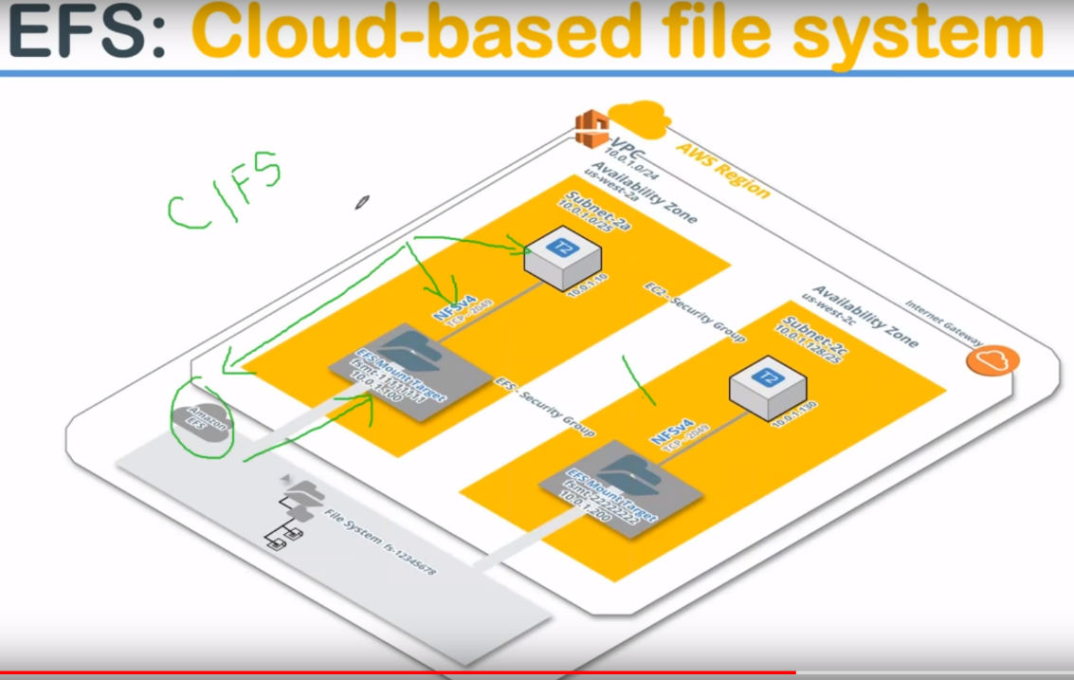

Outermost rectangle ,think of it as an AWS region (us Virginia region) . This region has to availability zones and inside those two availability zones inside that that is another bigger rectangle which is called as then availability zone. US west 2a and US west 2c..

I have two servers (T 2.micro) .In these servers, I have another EFS file systems accessible here and here. **What is happening here is**: This EFS file system sits outside your availability zones if you'll note. **This** area and it sits inside a region so it is not available outside the region but all of those AZ's can access it by using a mount point.

So you need to make sure you create a mount point in whichever availability zone you want to access the EFS and then you can configure your server to talk to it .

1. creating the mount point and
2. ensure that your firewalls are allowing this port. We are going to use NFS versison 4.. NFS is the network file system protocol
3. 3. Mount to linux servers

Your Linux machines also need to have NFS package installed.. If you are using Amazon Linux they come pre-installed with some version if not you will have to go ahead.. and install

Another here is Windows cannot be used for along with in NFS because you need to install Samba share or something called as the CIFS then also it doesn't mount directly that is you cannot use enough force directly in Windows.

**So only Linux machines can use EFS at this moment**

**DEMO:**  
we are going to create couple of servers and then we are going to write something from server A.. let us say and then we are going to see whether we can modify it from server B .

**So because it is going to happen in real time** .if we do something from B and it should be visible in A also.

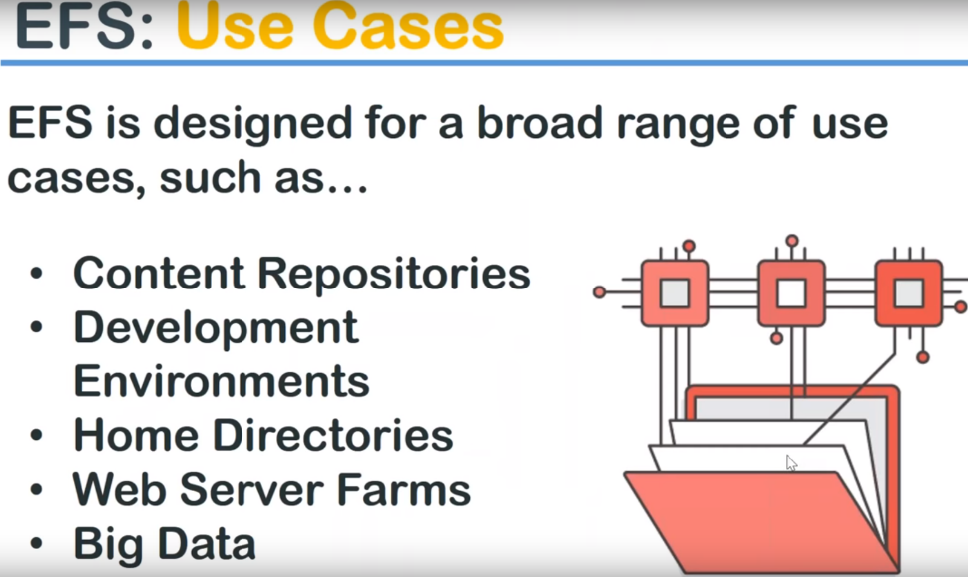

**Content repository** : let us say you have a group of developers and all of them want to access the same website they're building. So that one person might be building the home page other person might be building the whole page images and another person building the CSS stylesheets HTML pages.

So all of them all the elements come together to create the web page so they need to have the same content repository and they have to access the set latest files of everybody's creation so in those cases EFS file system makes a fantastic use case.

**development env:** let us say you have corporate.. how to documents and all your employees want to access those how to document then in those case.. you put in all the files because they are static files not going to change it much ..,**and then you configure access for all your employees is a shared Drive and then you can go ahead and probe them anytime or configure the website also on top of it lets a static website using s3 buckets.**

**home directories** let us say you create your employees how roaming profiles and every day they start up a new server then the home directory which is created on top of this EFS FS system will be automated whenever they start a new machine and they can need not worry about my desk is here might appreciate my desktop this year because their home directory is going to get mounted wherever they log in from and they will have access to all the files that they did yesterday or previous time and they logged into the machines.

**big data clustering** because all the data needs to be in one place for quite a lot of big data analysis and EFS being a scalable and high-performance storage' people configure their back-end with big data and web server forms where a batch processing or kind of data processing happens EFS becomes a fantastic use case for that so ..

**DEMO**

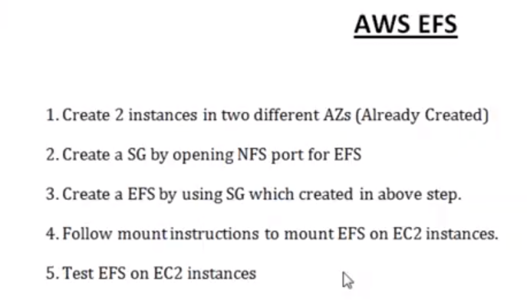

1.) Have 2 Ec2 instances: webserver1 and webserver2

2.) create a security group

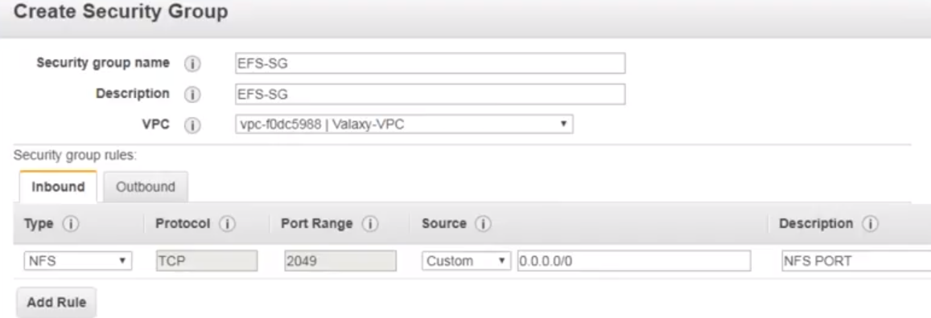

3.)create our EFS file system..

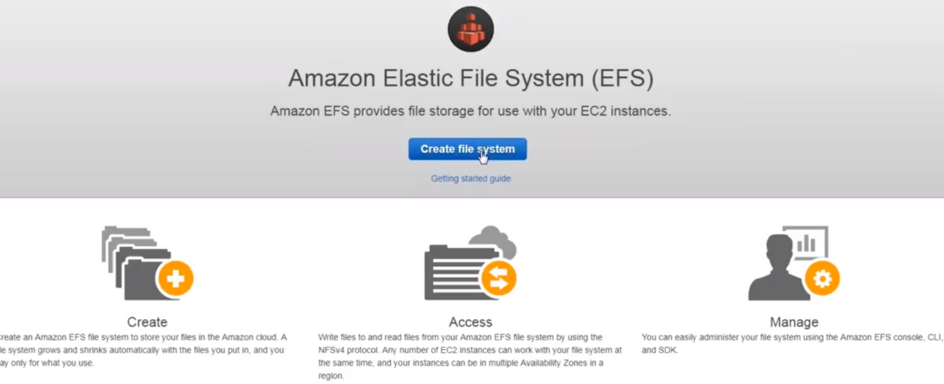

a.)click on create file system

b.) Select VPC, and it will show list of subnets we have…

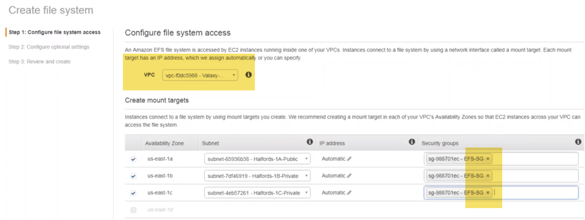

Select Security Group.. And it can be mounted in three availability zones.

c.) Select Disk type, add tags, Encryption:

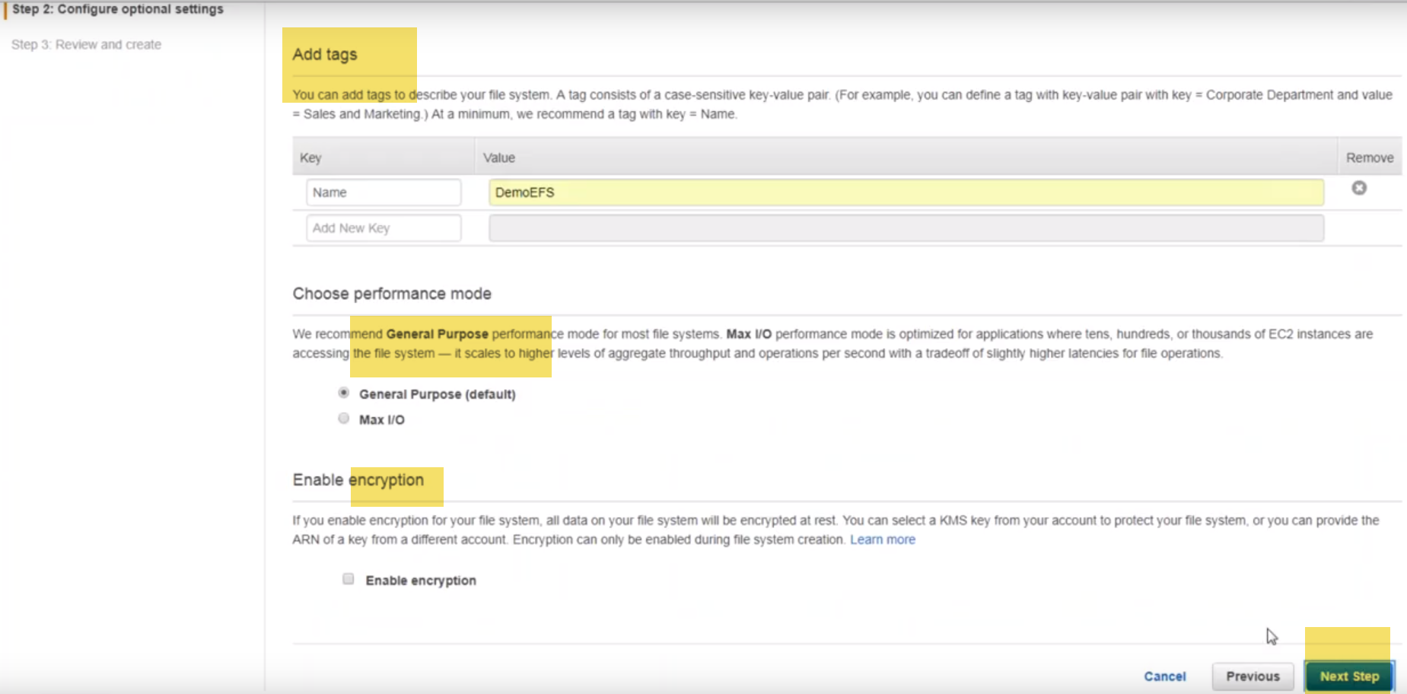

d.) Review:

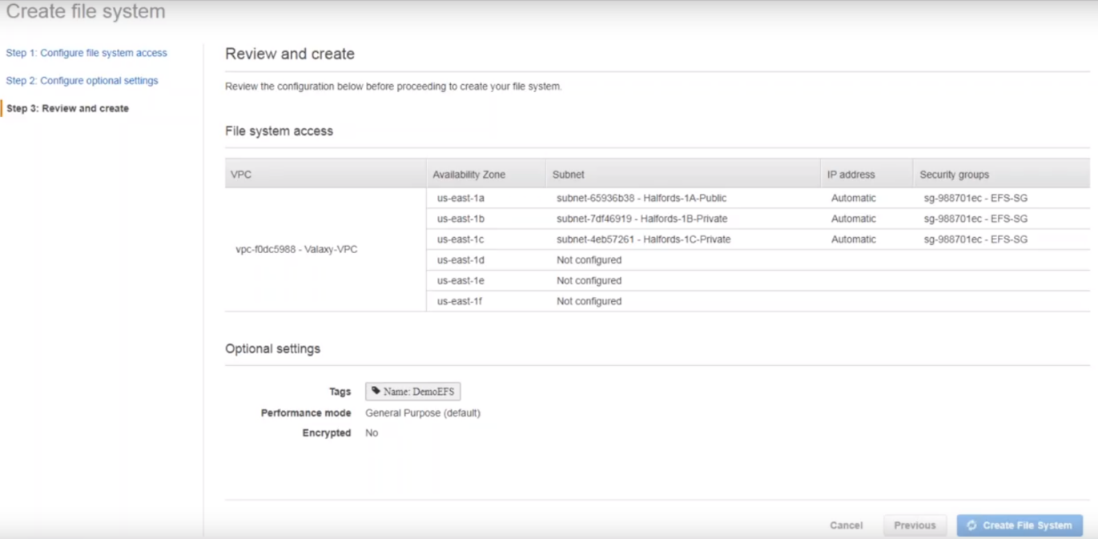

4.) mount instructions:

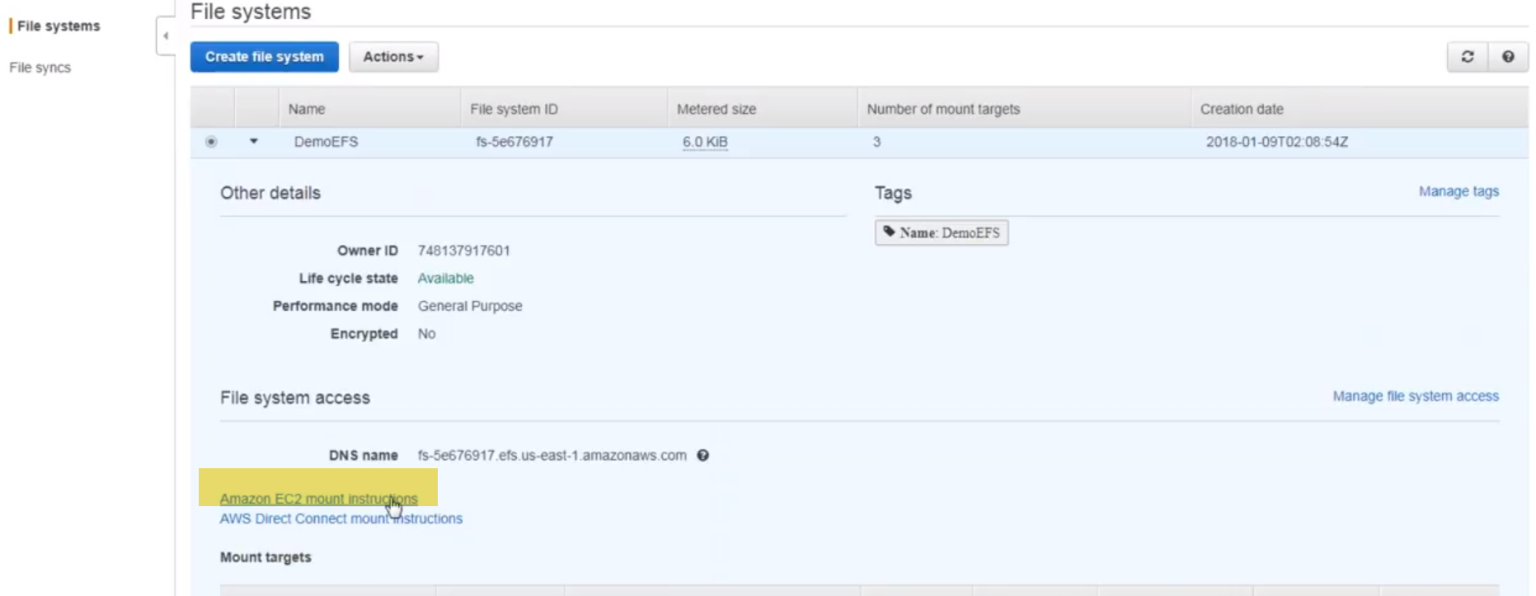

This link have a set amount instructions because these are the steps you need to follow to mount your EFS.

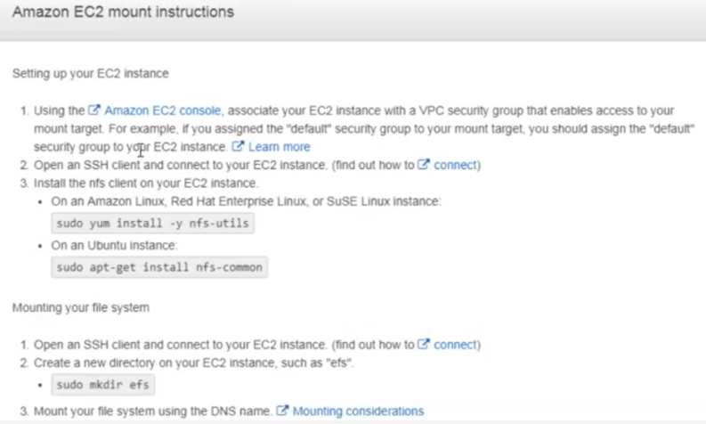

5.)logged into my server web server1 and web server2.

a.) Install NFS.

Mount EFS FS:

1. create a directory under root
2. Mount

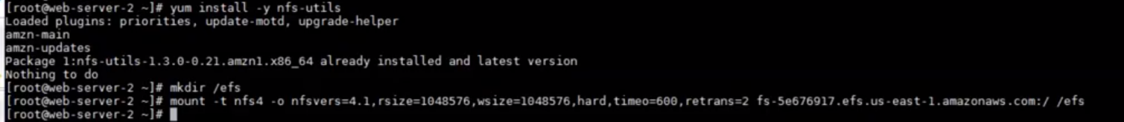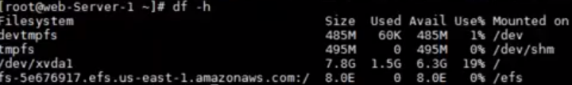

6.) 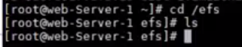

create some files on 1 , I could able to see the same files from the server2..

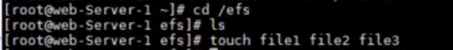

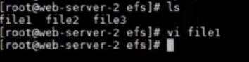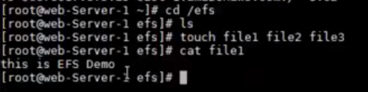

**DEMO-2:**

**1.)** Create security group for our EFS.

If search in Management console, you will not result for Security Group…Go toVPC, and then yto security Groups.

Create new security group:

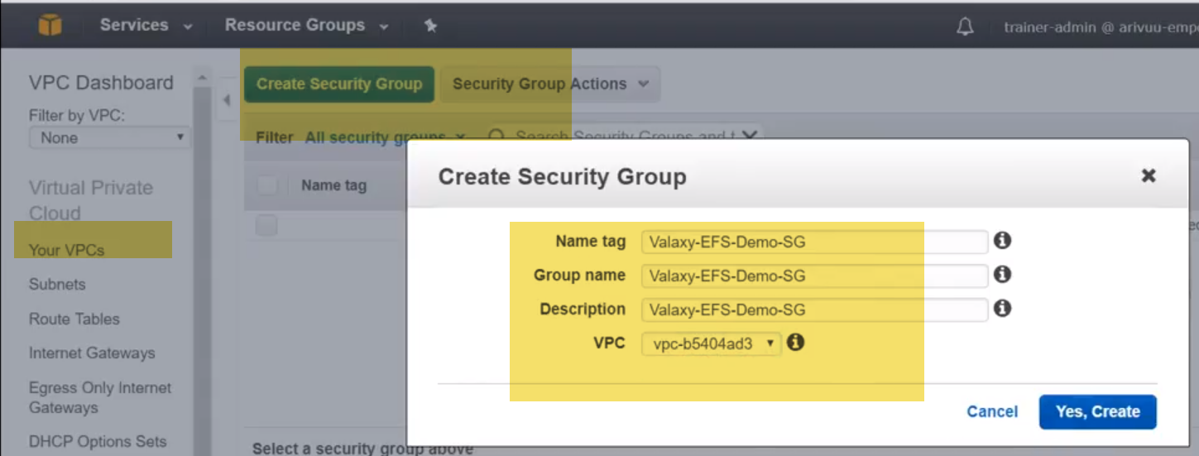

**Inbound rules** that is allowing who also access my services or resources residing inside this security group.

Think of it as a COMPOUND WALL around your house. So you are going to decide, who is going to come inside now. That is inbound or ingress.

choose or tcp/ip traffic , and in destination originating from my security group itself is allowed. 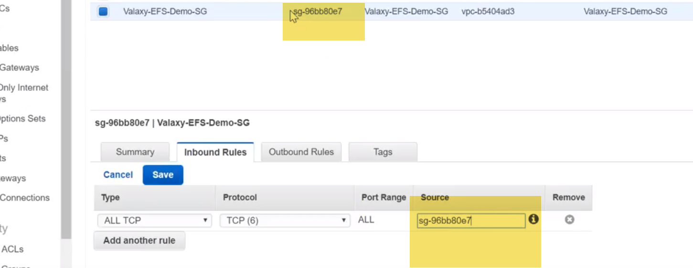

So all traffic from source of that security group is allowed.

I need to do an SSH.. since I don't know my current IP I can give my exact IP but I don't want to restrict it if I want to reboot or anything so I am going to give this right now and I repeat myself this is not a secure way of doing things in enterprise… **you will have a bastion host of a jump host or SSH server depending upon the company's name in terminology you have something and that server's IP will be given here so technically you login to that server and connect to your target machines.** 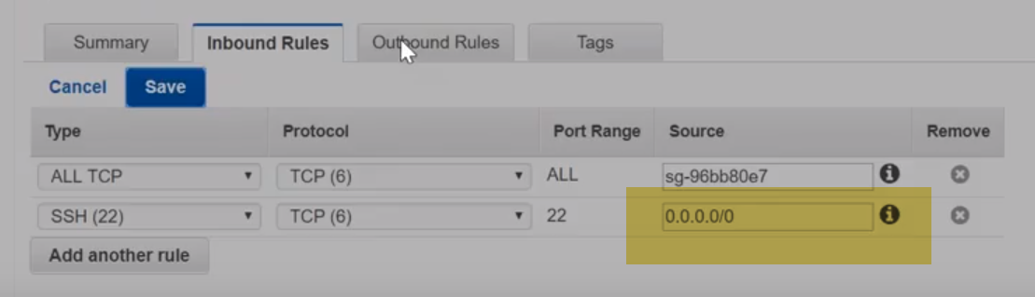

**outbound rules:** so everybody' whos is allowed inside is allowed to go outside

**elastic filesystem:**

here the VPC, see here there is a default one only. let me choose only like yesterday three subnets or three availability zones ABC only, and remove all these things.

Here I will give my security group..,because I don't want my servers and EFS to be different places.So I'm going to remove this one and add only Valaxy security group

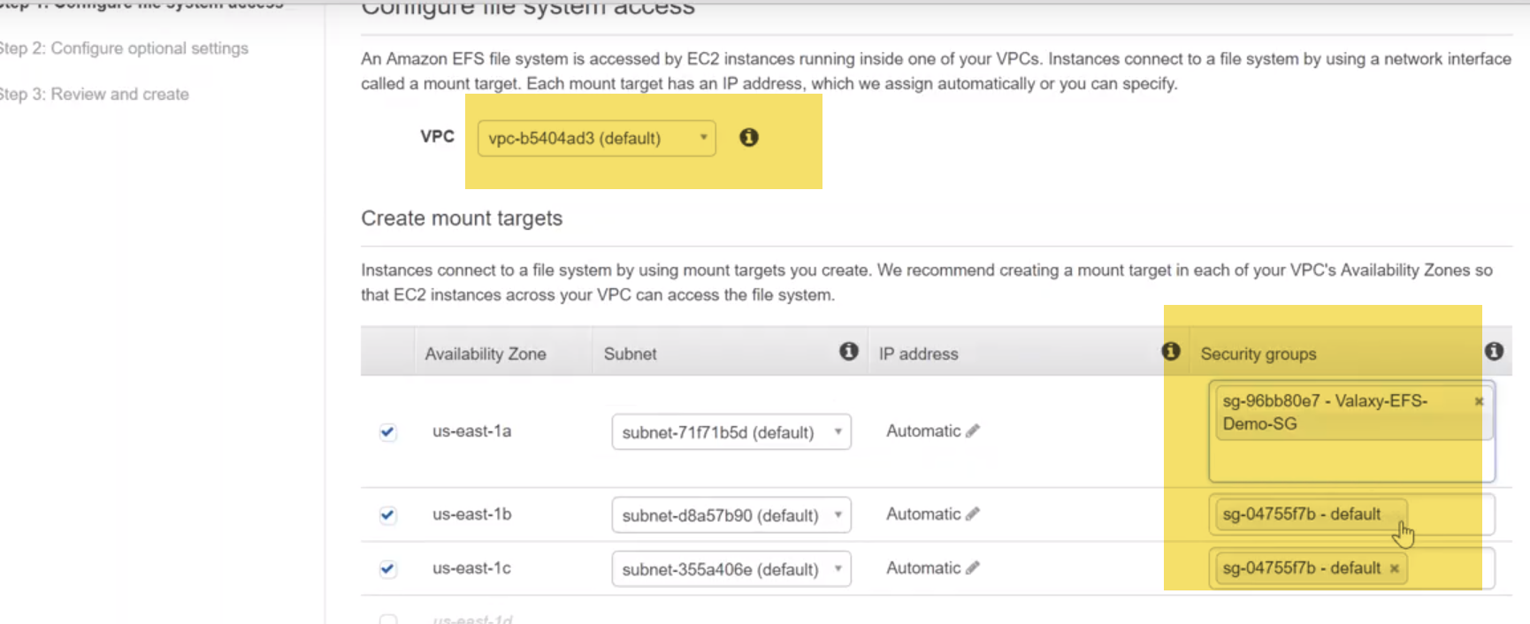

2.) tag, Storage, 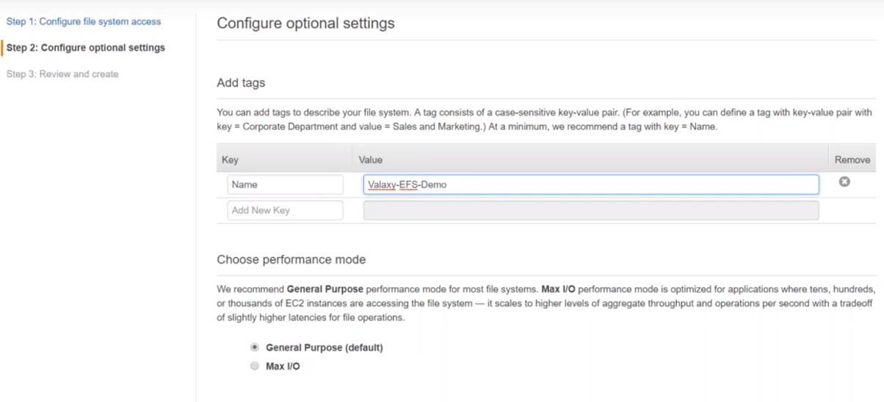

3.) review:

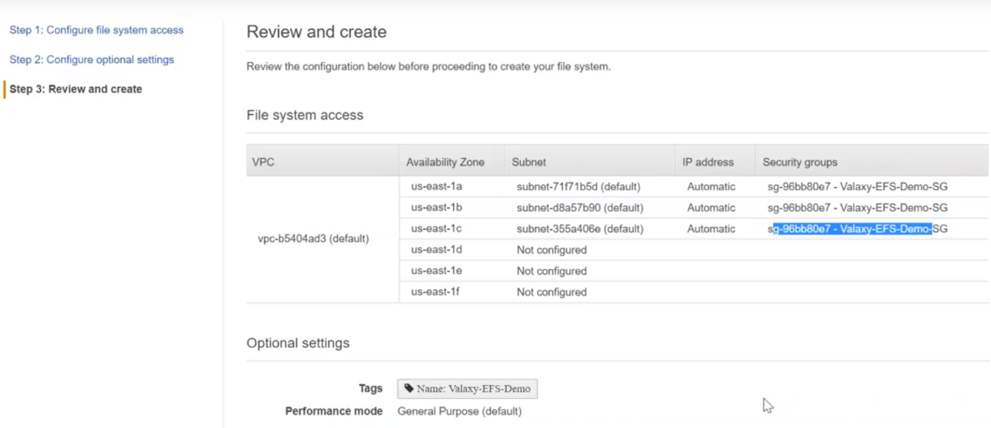

4.)scroll down …you can see here lifecycle state and itself is creating so it would be ready or available order the state will change that this when you can start mounting it or having access to the file system.

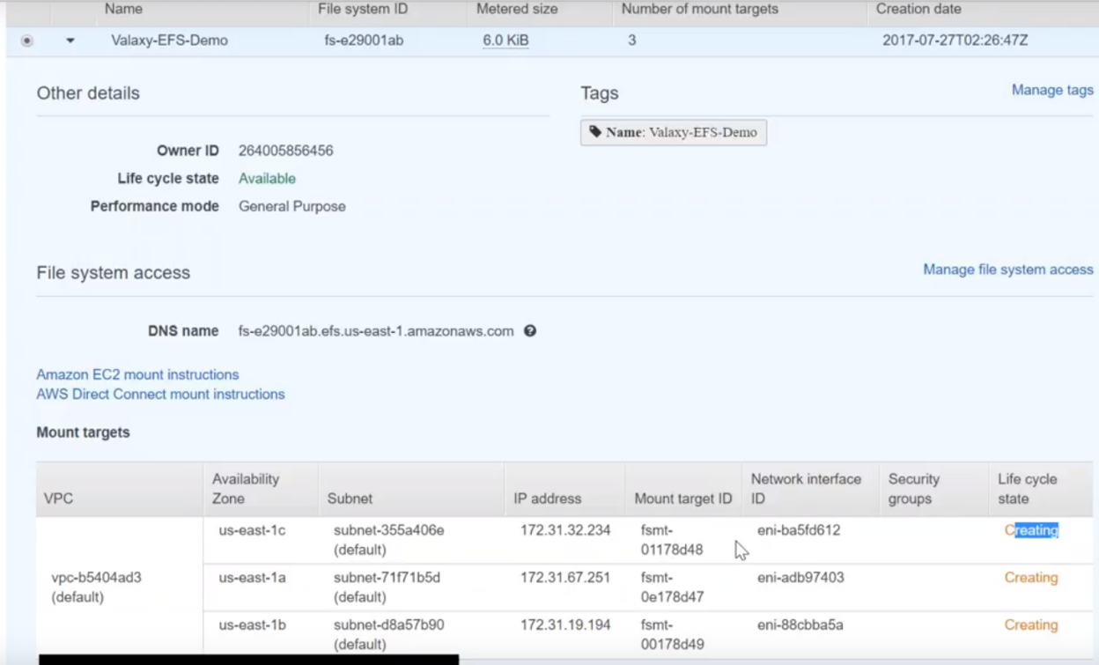

4.) I'm going to start three instances one and each availability zone default just click on default here I'm just going to ensure it is in one a US East1a

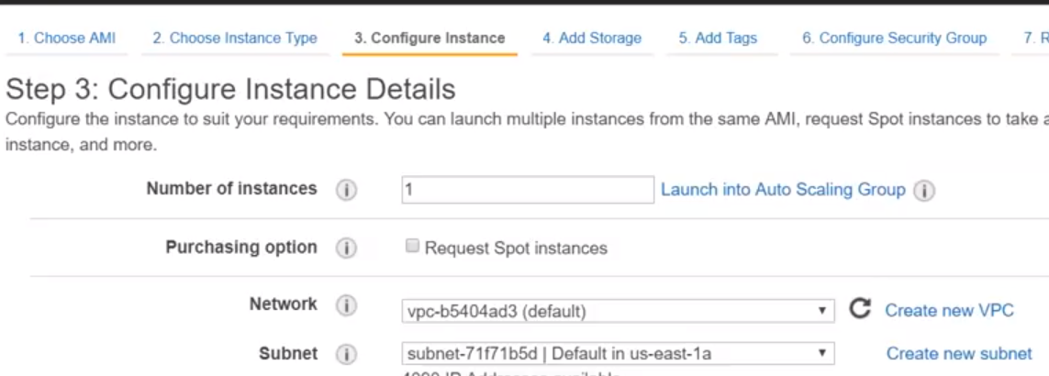

We nees to create 2 more instances..

The easiest way is : Clcik on instance you would like to launch more, 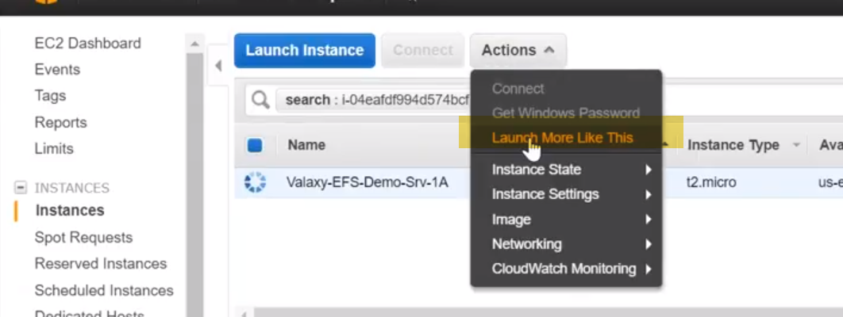

it will give you a summary of all the configurations about that instance and which over a configuration that you want to change you can change only that in my case I just want…

Only I want to change to 1b ..>Change Tag also..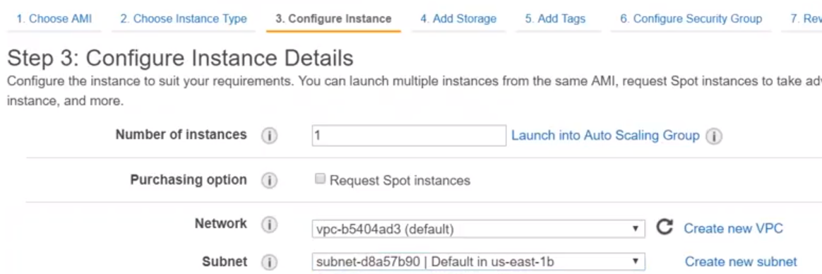

We have 3 servers 1A, 1B, 1C now…

Note: Choose PublicIp for Instances:

One way is Elastic IP..

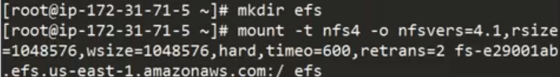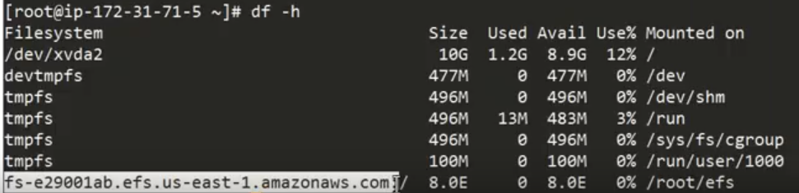

Size can be grown upto 8 Exa Bytes

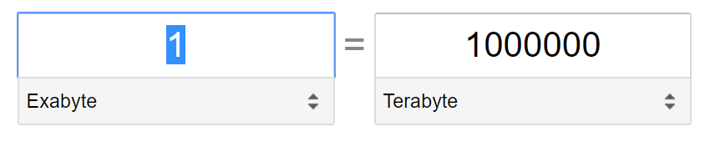

**FS is common to all the three servers**

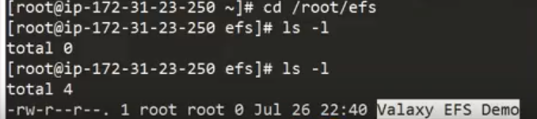

In Prod environment, we create one security exclusively for EFS ..and everybody who's connecting to EFS will be in other security groups ..so it might be your database layer it might be App. Layer.

You can go ahead and extend it across your on-premise infrastructure also so that is also possible to do that and here we use the domain name 419 you can in other words use it as an IP address also that is also possible

In our EFS dashboard, you can see here for each availability zone an IP address is also mentioned here. So you can mount the file system using just IP address without having a dns resolution also.

when you are creating a file system, it will ask you whether you want to set this up to automatic or you want a particular IP address to be configured for EFS .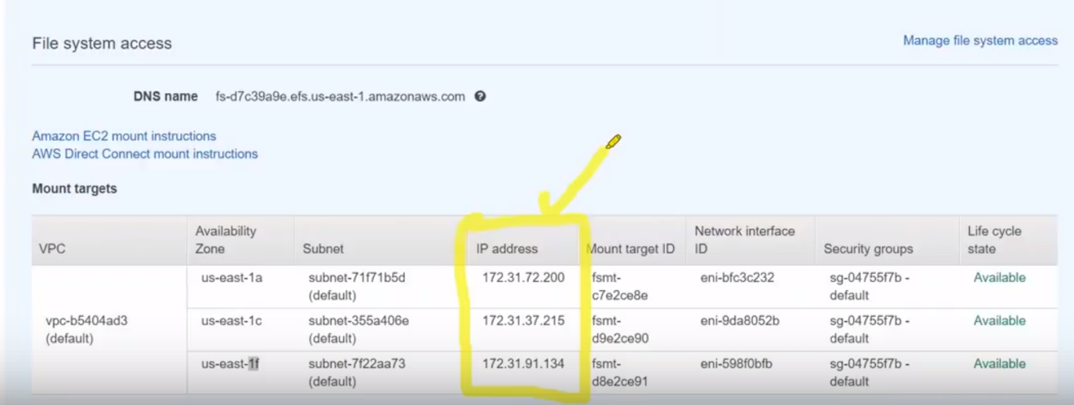.



Click on Amazon Rekognition:

Here, you can see here the service is not available all the regions and they have the state the three regions it is available.

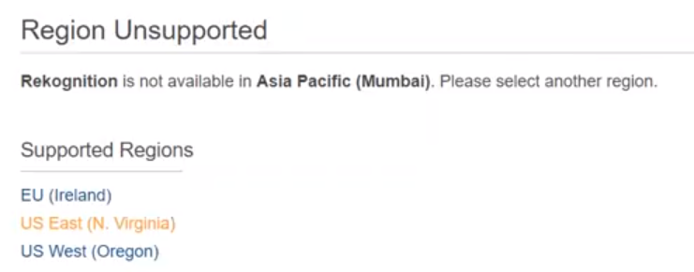

So let us go to Virginia.

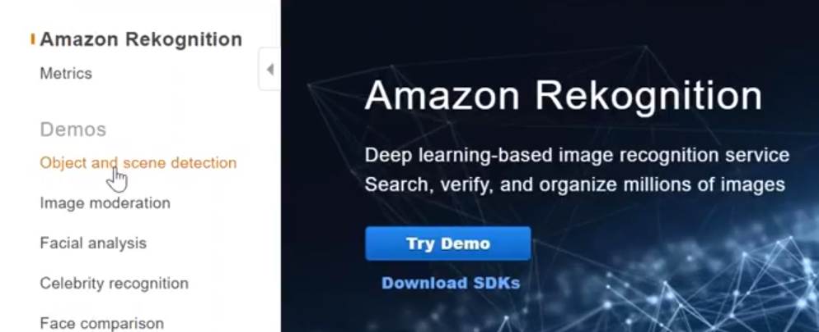

Amazon was already pre-loaded some images let us try to customize them later.

You can see here there is an image… you can see here is associated on the street in the middle of the stage and then if you just imagine us .

Amazon analyzed it and it says that it has recognized a skateboard, sport, a people-person and parking.

Go to google and pick up some image with outdoor and landscapes..

Pick up an URL to do our scanning… You can upload or Fill URL..

